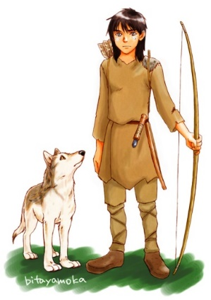

**Dates and information - Autumn 1 2024**

Welcome to Year 6 and the final year of primary school.

In this year, children are given increased responsibility within our school community, such as being House Captains and sports leaders and we’ll encourage them to take more responsibility for their own learning. They are the role models to other children in the school and being positive and confident really does become contagious for those around them.

We want year 6 children to aspire to be the best they can, communicate well and be curious about all that they learn. This is the year when all the learning from the primary years is consolidated and developed, enabling children to tackle their end of Key Stage 2 SATs with confidence. More importantly, as the year unfolds, we want to prepare them for moving to secondary school and the step-up in expectations and taking ownership for their learning.

**How you can help at home:**

* homework is completed on time and diaries signed each weekend
* keep hearing your children read aloud a minimum of 3 times a week. If already fluent then ask questions about what they have read eg characters/themes etc
* the children arrive on time
* keep talking to us about how things are going.

Year 6 -Torak

**Dates for your diary**

Year 6 residential and welcome meeting - 12th September 3:20pm

Brenscombe residential - 25th- 27th September

**Class Organisation**

**PE/Sport** Wednesday - Come to school in PE kit.

**Home learning** Spellings tested on a Monday, written homeworkset on a Monday and checked every Monday.

The homework set should take no longer than 20-30 minutes for each subject set. If it takes longer, or is causing problems at home let us know and we can help. put it right.

.

**Christian value**

Our Christian value this term is love and this is being discussed and thought about in collective worship, together with what that looks like in our school, classroom and at home.

**English**

**Texts to be studied:**

Voices in The Park by Anthony Browne

Warhorse by Michael Morpurgo

Alma (a short film)

**Text Genre:**

Surrealist picture book

Historical fiction

A descriptive suspense story

**Outcomes**

Writing from 2 differing points of view

Writing a character description

Comparing a book to a film

Writing a legend

**Maths**

**Areas to be studied:**

Place Value to 10 million

Rounding any number to any required amount

The four operations of number, including column multiplication and long division

Multiples, factors and prime numbers

**Outcome**: Security with mental maths for times tables and place value, using the 4 operations of number.

**Class: Year 6 Torak Base**

**Date: Autumn 1 2024**

**Topic/Focus for half term:**

**The British Empire**

**Science**

**Objectives**

Living things and their habitats: classification, characteristics and why we classify plants and animals.

Describe how living things are classified into broad groups according to common, observable characteristics including micro-organisms, plants and animals. Give reasons for classifying plants and animals based on specific characteristics.

**Outcomes**

Children are able to explain the 5 kingdoms of classification and are able to classify groups of living things. Children learn to work scientifically through planning and conducting experiments with yeast and plants.

**History**

**Objectives**

 Describe the main changes in a period of history (social, religious, political, technological and cultural)

Understand the concepts of continuity and change over time. Use dates and terms accurately in describing events.

**Outcomes**

Children will be able to answer the question: Why did Britain once rule the largest Empire the world has ever known?

**RE**

**Objectives**

Children study the 5 pillars of Islam and how Muslims show commitment.

**Outcomes.**

Children can write a discussion piece that answers the topic question: What is the best way for a Muslim to show commitment? They should contrast this with commitment in their own lives and what commitment means for Christians?

**Art /DT: 2D drawing to 3D making**

**Objectives**

 Explore drawing techniques such as grid drawing, using negative space, and mark making (including tonal value)

**Outcomes**

To transform drawings into a three-dimensional object.

**Other curriculum areas**

**PSHE:** Health and Wellbeing (self-image, friendships, medicines, addiction & e-safety)

**French:** Alphabet, numbers to 30, telling the time to the quarter hour, French schools and travelling to school.

**PE:** Outdoor Learning and Dance